**CS 345 Week 3 Homework**

Answers are in yellow

Make sure your answers are in numerical order!

1. For this problem, you cannot use Putty! Login to the VirtualBox Linux VM. Grab a screenshot of the default text window after you login in (make sure the VirtualBox window header is showing in your screenshot). Enter the command to tell the system to switch from text mode to graphical mode (you can just write the command that you issued in your answer below). Next, login to the graphical interface and grab a screenshot showing the VM is now running in graphical mode (make sure the VirtualBox window header is showing in your screenshot). You can then logout of the GUI.

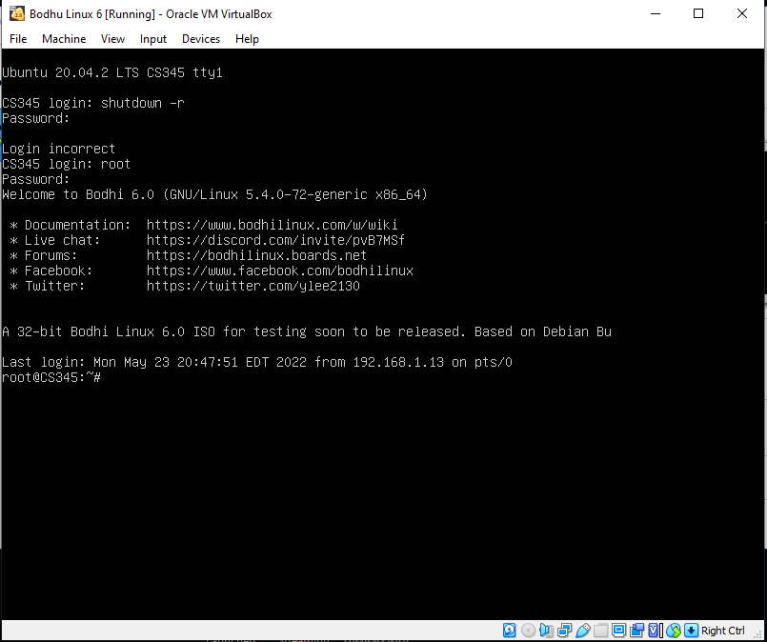

sudo systemctl set-default graphical.target

sudo reboot

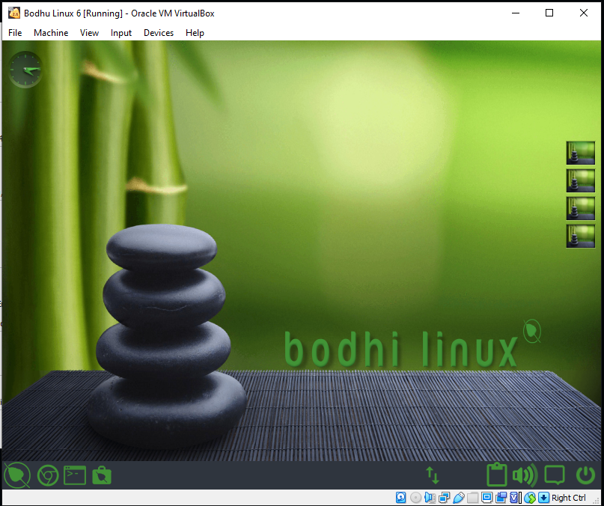

1. Make the necessary modifications to the appropriate files to add an alias for dir, such that an ls –al | more is performed. This change needs to be made so that the alias is set every time any user logs in. (Run the commands and show the necessary output – no screenshots)

root@CS345:~# alias dir = 'ls -al |more'

root@CS345:~# nano .batchrc

root@CS345:~# dir

total 76

drwx------ 8 root root 4096 May 30 16:54 .

drwxr-xr-x 19 root root 4096 May 15 17:39 ..

-rw------- 1 root root 3729 May 30 16:54 .bash_history

-rw-r--r-- 1 root root 3135 May 30 16:54 .bashrc

drwx------ 3 root root 4096 May 15 17:58 .cache

drwx------ 2 reguser root 4096 May 23 21:18 copyspot

drwx------ 3 root root 4096 Mar 8 2021 .dbus

drwxr-xr-x 4 root root 4096 Mar 5 2021 .elementary

-rw-r--r-- 1 root root 30720 May 23 21:18 hw2.tar

drwxr-xr-x 3 root root 4096 May 15 17:55 .local

-rw-r--r-- 1 root root 161 Dec 5 2019 .profile

drwx------ 3 root reguser 4096 Mar 5 2021 .run

1. Enter the command export PS1="\d $PS1" (Run the command and show the necessary output – no screenshots) Explain what this command did and what the various parts of the quoted string mean. Log out and then back in after doing this to set things back to the way that they were.

root@CS345:~# export PS1="\d $PS1"

Mon May 30 root@CS345:~#

This command changes the prompt to include the current weekday, month, and date before the user logged in.

The \d represents the date in the Weekday Month Date format. PS1 is the environmental variable is the primary prompt variable.

1. Create an environment variable called TEST_VAR which is set equal to the string "This is a test." Export this variable and then create an alias called tv, which is equal to "echo $TEST_VAR" What happens when you type tv? (Run the commands and show the necessary output – no screenshots)

root@CS345:~# export TEST_VAR="This is a test."

root@CS345:~# alias tv="echo $TEST_VAR"

root@CS345:~# tv

This is a test.

root@CS345:~#

When running tv it shows the contents of TEST_VAR

1. Now start a new shell by entering the command bash. What happens when you type tv this time? Why did this happen? Type the exit command to leave the second shell you started. (Run the commands and show the necessary output – no screenshots)

root@CS345:~# bash

root@CS345:~# tv

Command 'tv' not found, but can be installed with:

apt install treeviewx

root@CS345:~# exit

exit

root@CS345:~#

When typing tv this time, it errors out saying the command cannot be found. This is because we are within a second shell, where tv has not been defined yet.

1. Why do we have environment variables? Who/what uses them?

We have environmental variables because they allow customization of how the system works and the behavior of applications within the system. Each user is able to have a uniquely configured environment. The environments hold information like settings for the shell and other useful programs through providing info on the system settings, OS, and execution environment. They are commonly used by all users and the shell.

1. Show the last several commands that you’ve issued and “replay” one of them. (Run the commands and show the necessary output – no screenshots)

root@CS345:~# fc -l

244 nano .bashrc

245 alias dir = 'ls -al | more'

.

.

.

255 export TEST_VAR="This is a test."

256 alias tv="echo $TEST_VAR"

257 tv

258 bash

root@CS345:~#

root@CS345:~# !257

tv

This is a test.

root@CS345:~#

1. Create a symbolic link in root’s home directory to /etc/security. Show that this worked with an ls –l command. (Run the commands and show the necessary output – no screenshots)

root@CS345:~# ln -s /home/etc/security link.txt

root@CS345:~# ls -l

total 36

drwx------ 2 reguser root 4096 May 23 21:18 copyspot

-rw-r--r-- 1 root root 30720 May 23 21:18 hw2.tar

lrwxrwxrwx 1 root root 18 May 30 22:05 link.txt -> /home/etc/security

root@CS345:~#

1. Using a single ls –a and grep command, how would you list the name of all of the files in /sbin starting with the letter a or the letter b or the letter d? (Run the commands and show the necessary output – no screenshots)

root@CS345:~# ls -a /sbin |grep "^[abd]"

aa-remove-unknown

aa-status

aa-teardown

accessdb

addgnupghome

addgroup

add-shell

adduser

agetty

alsabat-test

alsactl

alsa-info

apparmor_parser

apparmor_status

applygnupgdefaults

aptd

arp

arpd

arptables

arptables-nft

arptables-nft-restore

arptables-nft-save

arptables-restore

arptables-save

aspell-autobuildhash

auibusy

aumvdown

auplink

badblocks

biosdecode

blkdeactivate

blkdiscard

blkid

blkzone

blockdev

bridge

debugfs

delgroup

deluser

depmod

devlink

dhclient

dhclient-script

dmidecode

dmsetup

dmstats

dpkg-preconfigure

dpkg-reconfigure

dumpe2fs

root@CS345:~#

1. Create a file that contain 10 lines. Each line should consist of one word. Make sure that the lines are not in alphabetical order. Now use the sort command to order the contents of the file. (Run the commands and show the necessary output – no screenshots)

root@CS345:~# pico hw3

root@CS345:~# cat hw3

one

two

four

six

eight

ten

nine

purple

alphabet

hundred

root@CS345:~# sort hw3

alphabet

eight

four

hundred

nine

one

purple

six

ten

two

root@CS345:~#

1. Carefully select a daemon running on the system and do the following: (choose carefully, or else! – it’s exploration time)

* Show how stop a daemon
* After the daemon has stopped, show how to start the daemon back up

Explain why you would want/need to do this. (Run the commands and show the necessary output – no screenshots)

root@CS345:/# /etc/init.d/uuidd stop

Stopping uuidd (via systemctl): uuidd.serviceWarning: Stopping uuidd.service, but it can still be activated by:

uuidd.socket

.

root@CS345:/# /etc/init.d/uuidd start

Starting uuidd (via systemctl): uuidd.service.

One reason behind disabling daemons is it can increase boot sequence time. Since they can always be activated later, disabling certain daemons can be beneficial in certain situations

1. Find all files that were modified/created since yesterday in the /proc subdirectory system only. (Run the command and show the necessary output – no screenshots)

root@CS345:~# find /proc -maxdepth 1 -type f -mtime -1

/proc/fb

/proc/dma

/proc/keys

/proc/kmsg

/proc/misc

/proc/mtrr

/proc/stat

.

.

.

/proc/execdomains

/proc/filesystems

/proc/kpagecgroup

/proc/sched_debug

/proc/vmallocinfo

/proc/pagetypeinfo

/proc/sysrq-trigger

/proc/version_signature

root@CS345:~#

1. Touch a new file and then find all files on the system that are empty. (Run the commands and show the necessary output – no screenshots)

root@CS345:~# touch testfile

root@CS345:~# find /root -type f -empty

/root/.cache/motd.legal-displayed

/root/testfile

root@CS345:~#

1. Explain what the results of the command *file /sbin/useradd* means. (Run the command and show the necessary output – no screenshots)

root@CS345:~# file /sbin/useradd

/sbin/useradd: ELF 64-bit LSB shared object, x86-64, version 1 (SYSV), dynamically linked, interpreter /lib64/ld-linux-x86-64.so.2, BuildID[sha1]=65ff024ba1111b0ce86873f9b22b9c6eded9c501, for GNU/Linux 3.2.0, stripped

root@CS345:~#

The results of the command explain what kind of file useradd is. For example, it states that the file is dynamically linked meaning the code for it is located and loaded on launch.

1. Explain how you could modify the way that the rm command operates so that it behaves more like the Windows recycle bin.

You could modify rm to transfer those selected files into another directory title “Trash” or “Recycle Bin”. If the directory does not exist it would create it, otherwise just insert the files into it. To empty the “trash” the user can just delete the directory with *rm -d trash.*